Published in Kybernetes special issue for Felix Geyer 2006 no. 3-4: 403-425.

The necessity of Trans-Scientific Frameworks for doing Interdisciplinary Research

Developed from a conference paper for Paradigms lost and Paradigms gained: Negotiating Interdisciplinary in the 21’st century, Calgary, May, 2001.

Associate Professor Søren Brier (M.Sc., Ph.D.)
The Royal Veterinary and Agricultural University,
Dept. of Economics and Natural Resources
Copenhagen Denmark, sbr@kvl.dk

Purpose of this paper
The purpose of this theoretical research article in philosophy and theory of science is to argue for the necessity of developing transdisciplinary frame works in order to be able to interact interdisciplinary.

Findings
Through reflecting on interdisciplinarity and the prerequisites of doing scientific and scholarly research the article develops a non-reductionistic and transdisciplinary view on human knowing in the light of the growing development of interdisciplinary practices and sciences. It is argued that there is at present an incompatibility between scientific and phenomenological approaches to cognition and communication A broader framework is therefore needed to encompass both if we want to make coherent theories and models in this subject area. The work therefore focuses on the relation between information science and semiotics and creates a framework for the analysis of both meaning and truth.

Research limitations
The article develops a suggestion for such a framework for cognitive and communicative studies by critically analyzing and adjusting the disciplinary matrixes (Kuhn) behind the analyzed paradigm for conceptual consistency with its framework and its scope.

What is original
That a trans-scientific framework, which is suggested as a basis for the sciences and humanities to understand themselves in relation to other kinds of knowledge such as philosophy, art, religion, political ideology etc. New also are the visual structural models.

Practical implications
They have to be judged on both how well their descriptions fit better with what actual goes on in the sciences and humanities than others, as well as their usefulness to function as a common map coordinating interdisciplinary work.

Research limitations/implications
The framework is very abstract here in the description. It has to be developed in detail and its effect demonstrated in practical examples.

Key words: Transdisciplinarity, interdisciplinarity, trans-scientific framework, Cybersemiotic, information science, semiotics

Information science and semiotics

The present information science theories are most often constructed within a functionalistic, objectivistic, scientific paradigm and enlarged by an unspecific systems and cybernetics background incorporating non-linearity, chaos, self-organization, dissipative structures, hyper cycles and emergent principles, but still based on a basic physicalistic idea of reality. This kind of information theory attempts to be the metaphysical framework behind the information-processing paradigm in cognitive science that again is the dominating paradigm explaining both the computer and the cognition and communication of living systems. The problem is whether or not this pan-informational paradigm will ever arrive at a reasonable and consistent description of the nature of meaning and signification in living, social and linguistic systems. As Stonier (1997) admits, the attempts to quantify meaning must be seen as preliminary. It is also true that the strategy of the information-processing paradigm is to go “beyond” the influence of culture, which is a problem as cultural influence is recognized in humanities and social science to be an important part of the production of meaning. The move towards trans-disciplinarily has gone from mechanistic atomism to a more field-oriented energy view connecting relativity and thermodynamics, and, finally, via the introduction of the information concept there is a shift to understanding machines, intelligence and language.

On the other hand a more and more pan-semiotic view has developed from the humanities and social sciences. With the growing recognition of the pragmatic, transdisciplinary and evolutionary orientation of Peircian semiotics, semiotics is on the move into the area of the sciences (see figure 2). The first important move in that direction has been the establishment of a biosemiotics by Thomas Sebeok (inspired by the Umwelt theory of von Uexküll) to encompass all living systems (Sebeok (1976).

Semiotics brings phenomenological and informational theories of meaning in systematic contact with linguistics and “the linguistic turn”. With Peirce’s semiotics, the boundary between nature and culture is superseded. In biosemiotics, we find a new paradigm for the understanding of the communicative structure and processes of the living. Some researchers (Merrell, 1996, Deely 1990, 2001) now claim that semiosis cannot only occur in living systems but also in mechanical and physical systems. Is it reasonable to conserve the idea of non-semiotic interactions in nature such as physical causality?

Figure 1: The relevance of the bottom up informational view and the top-down semiotic view in the area of the foundation of information science: On the left side a hierarchy of sciences and their objects going from physics to humanities or vice versa. On the right side an illustration of the two most common scientific schemas for understanding and predicting communicative, cognitive and organizational behavior: 1. The semiotic top-down paradigm of signification, cognition, signal transmission (information theory) and A.I. the width of the two paradigms is in correlation with the various subject areas showing an estimate of how the relevance of the paradigm is usually considered.

Peirce’s triadic semiotics is based in an ontology where qualities and feelings are firsts as possibilities. Thingness, forces and will are necessary seconds, and relations and habits, as sign processes and natural laws, are Thirds. Matter internally carries Firstness as qualities, feeling and mind with it (hylozoism). See figure 2.

Figure 2: A graphical illustration of C.S. Peirce’s triadic philosophy and semiotics in epistemology, ontology, evolutionistic theory, psychology and logic of cognition. Quoted from Brier (1999c).

There is continuity between mind and matter as opposed to mechanistic and physicalistic ontologies. One basic question that arises is then; are we forced to view the pan-informational and pan-semiotic as mutually exclusive, as complementary views or can they be seen as aspects of a deeper more general framework? Is there any way to unite these views in a broader framework: A Cybersemiotics, for instance? Such a framework would also be a contribution to the research programme of sociocybernetics (Geyer, 1995).

The Mechanistic Versus the Phenomenological Approach

The lack of a recognized place and value of phenomenological knowledge in the general mechanistic scientific ontology, that still seems to be the only generally accepted background for the transdisciplinary areas to build on, is now going to be discussed. (See Figure 3). The new area of consciousness studies is working hard to solve this problem, mostly on the basis of an informational paradigm. See for example the ongoing debate in Journal of Consciousness Studies.

Figure 3: The mechanistic and phenomenological description systems are isolated from each other and blind to each other’s conceptual worlds. Quoted from brier (2000c).

Realizing that we make science with our mind an eliminative materialistic view of mind is, seen from a philosophy of science-viewpoint, self-contradictory. Scientific knowledge is constructed socially by subjective minds interacting with nature. It, therefore, seems obvious that we have to admit that our inner “subjective” world is as foundational a part of reality as “objective” external nature and “intersubjective” social worlds. But western scientific culture lacks a transdisciplinary framework that can encompass all three worlds without reducing any of them to byproducts of the development of one of the others. We need such a non-reductionistic framework more than ever as our basic problems often arise in the gaps between the recognized disciplines. Interdisciplinary work needs a transdisciplinary framework for mutual orientation and context determination. A sort of common map, so to speak, on which to point out, recognize and understand each other’s territories..

As a start, let us put up a more modest ontological framework than the mechanical and the subjective, idealistic or constructivistic. Let us postulate as little as possible about the reality we are going to investigate with scientific methods. Ontologically we cannot say much about reality, except that it is very complex and dynamic and contains both mind and matter. Further it has structures and causal relations of a certain stability, which can be modeled mathematically. We further also have to admit that there are aspects of reality that are beyond measuring.
Figure 4 is a model of such a view.

Figure 4: The view is that reality, as a whole cannot be expected to be scientifically explainable, so the realm of explanation is only an island in the bit unexplainable realty (1) parts of it we can explain, not in a logic-rational way, but only through myth and other narratives. They provide the rationality of rationality. (2) So now only a part of those explanations are rational (3). So what is considered rational is partly determined by the mythical/metaphysical framework. Of course some explanations are mathematical (4), and some are logical (5). Some are both without being computational (7), and the computational realm of explanations (6) is of course the essence of them both. These are the aspects of nature we have focused most on, because we had the most success in handling them. But they represent only a small fraction of the existing systems. The classical physical systems are a major part of the computational describable systems. Quoted from Brier (2000c).

The model in Figure 4 assumes as little as possible about reality, assuming it is hyper complex, meaning that it has differences, regularities and stable patterns of force and matter, but they are probably so inexhaustibly complex, and work on so small and very large size -- and time scales -- that no single system of knowledge can reduce it to something comprehensible for human rationality. We are forced to frame certain questions and get partial answers. Out of this every culture carves or stamps out a reality within the manifest and obscure constraints of nature. In most cultures the framework starts as mythological making of a history of the creation of the world, its parts, forces and living systems. This narrative sets the frame for rational thinking and explanations. In our culture we ended with a foundation where each person is seen as an immortal soul, for one lifetime placed in a material body, given one chance to defeat mortal sin or get lost in the darkness. Ever since Descartes, the world of the soul and the material world are considered completely qualitatively different and separate, and the body is considered a part of the material world. Not long ago, the Pope acknowledged the theory of evolution, however, only for the body. The immortal soul is given by God. This world came to be considered mechanically ruled by eternal and universal laws of a mathematical nature.

In the later development of positivism, logical empiricism, the objectivistic, most often eliminative materialistic view, was developed, where subjective mind is not considered to have any independent existence, and hardly count as real as such. It was/is considered not to have any causal influence on the body. The free will is considered an illusion and introspective data scientifically worthless. See Figure 5 for a visual model.

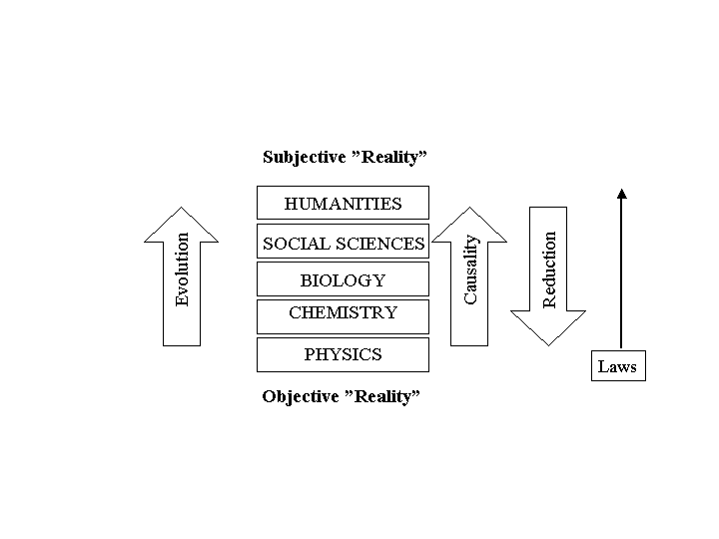
Figure 5: The traditional objectivist, eliminative materialistic and reductionist view of scientific knowledge, what is real and where causality comes from.

These ideas were finally applied to the body and later to the mind/brain, eliminating views of any particular spiritual quality of the mind. Since the Second World War there has been a growing belief in the existence of a common algorithmic foundation for nature, body and mind. Our inner world of desire, volition, emotion and meaning seems left out.

I suggest that the dualistic idea of transcendental, universal and eternal mathematical natural laws and an algorithmic program behind intelligence and language is rejected for its lack of ability to include the phenomenological and existential perspective of science, and the practical knowledge beyond. Instead, we have to realize that this framework only works well for a limited section of the existing systems.

I will, as an alternative, suggest a view of knowledge seen as embodied self-organized signification systems based on metaphysical frameworks in social practice. The interpretation of signs in a systematized knowledge framework is actually where the medical sciences started in the classical Greek tradition of Hippocrates. This non-reductionistic framework promises to open towards a non-Cartesian trans-disciplinary understanding of the basis for the generation and communication of knowledge in society without giving up what we have gained through the rigor and the methods of the sciences and the logic of philosophical analysis. In a recent paper in Systems Research and Behavioral Science Yearbook (Brier 2000c), I suggested the following trans-disciplinary philosophy of science- model of knowledge systems, where knowledge is seen as a product of embodied, conscious, language mastering social persons. These develop and cultivate several types of knowledge. See Figure 6.

Figure 6: The present figure illustrates that not only in the area of the sciences and the arts are there different types of knowledge areas and types; but there are qualitatively other kinds or types of knowledge than the purely scientific ones. In a modern view Episteme is algorithmic models mostly of linear systems, but based on the belief that they mirror deep mathematical functions in nature as such. This was also the base of Plato and Aristotle’s use of the term. For Aristotle, God was pure form. Galileo carried the view into classical mechanics. But like all other knowledge systems they spring from language, using conscious, embodied social humans; except tacit knowledge that often springs from bodily experiences and sometimes intuitive sources. Quoted from Brier (2000c).

Thus, the different knowledge systems are seen as evolving from the human condition, biological, phenomenological, as well as social and the surrounding reality. This is a rather new outlook compared to the totalitarian tendencies of knowledge systems, which has been with our culture for the last 1000 years. Let me explain further.

The explanatory quest of the sciences since religion lost its power
Many of my colleagues in the social sciences and the humanities fear trans-scientific frameworks because previous ones have been very reductionistic in mechanical, functional or ideological ways. Most of these frameworks lack self-reflection and modesty in relation to their own truth, value and comprehensiveness. I hope not to fall into any of these traps when I include signification, qualia, and the importance of our body-ness in the present frame.
Still, many scholars will ask what interest lies behind the formulation of the framework. The answer is that despite being aware of the cultural and social context of all our thinking, I believe in the possibility and need for conscious constructions and discussions of basic philosophical standpoints, contemplating the limits and possibilities of human knowing. Such a standpoint will be developed parallel to the analysis of the limits and inconsistencies of the prevailing scientific paradigms.
My interest in establishing a new framework is to create a third culture, transcending the incommensurability between C.P. Snow’s two cultures; science-technology versus humanistic and social science. This stance is again based on an internal and critical realism, a view beyond pragmatism, but within C.S. Peirce’s pragmaticism. It is an attempt to make a common map onto which different viewpoints can be plotted, their subject areas characterized and compared with other approaches. With this framework I hope to further the dialogue between science, the humanities, social science, philosophy and the existential quest.
It is important to notice that when researchers within humanities and social science do philosophy and sociology of “science”, they do it within their subject area of society and culture. As such they provide, as ultimate explanations, sociological and historical descriptions of the formation processes of institutions and institutional practices of producing knowledge, but most often without any interest in concepts of truth, relating to some kind of independent reality.
The scientist who has become a philosopher of science does not feel tempted to explain the theories and methods of science from the viewpoint of a social-cultural history alone. He wants to know if -- or rather -- how we have made progress or faults in our development of science through both revolutions and normal science periods. The relation of our knowledge with an outside theory is crucial to him. He is, therefore, forced to look for a meta-scientific framework that is also meta to humanities and social science, in order not to have the whole idea of science to be consumed by the relativism of social constructivism. As originally educated as a biologist, it is this situation that forces me into philosophical and metaphysical analysis of the frameworks behind the present conceptions of science, much in the way the problem is stated by Michael Luntley in his book, Reason, Truth and Self:
We need to legitimize a use of the concepts of truth, rationality and self against the postmodernist critique. To achieve such legitimation it is not sufficient to criticize the theories on the basis of which the postmodernist claims are made. What is required, therefore, is a description of how, given the opacity of all experience, the concepts of truth, rationality and self can still have a legitimate role to play in the business of making sense of our lives. This book is, if you like, an essay in descriptive metaphysics. It is an essay which describes the structure of and connections between the key concepts of truth, rationality and self. It is an attempt to provide the metaphysics or model that shows how truth, rationality and the self work; it is a model to replace the defunct model inherited from the Enlightenment.
(Luntley, 1995, p. 21-22)
That is the spirit although we go about the task differently.

Ever since Galilei, through experiments and theories of an earthly science combined with his enforcement of Copernicus’ view of the heavens confronted the Catholic Church’s worldview, religion as the upholder of a meaningful world has been challenged. The evolution of classical (mechanical) physical science and its concept of universal mechanical natural laws was on of the most important instruments to break the Church’s worldview and our view of our own place in it. The worldview of the Catholic Church was one of the core foundations of the culturally produced meaningfulness of the individuals’ personal life. It told us where we came from, where we could go and what the meaning with our lives was.

Ever since the philosophers of the Enlightenment and later Marx and Engels broke the view of the social order as ‘heavenly sent’, a further disturbance in our belief in that everything in our social order was ‘as it should be’ was created. Darwin destroyed our belief in man coming from a higher and meaningful place and thus being endowed with a meaningful destiny, accordingly. He destroyed the idea of the human soul as descended into our body from the ‘divine above’. Freud spoiled our idea of being perfectly conscious and rational beings in control of our language and ourselves and own drives. Nietzsche finally declared God ‘dead’, and he and other philosophers left us in a nihilistic vacuum with no universal meaning and values left.

Since then man has more and more looked to science for new explanatory stories of himself. It has lead to what Ilya Prigogine and Elisabeth Stengers called ‘World Formula Thinking’; the belief that final explanations can be found through science, especially through algorithmic approaches such as in artificial intelligence, the search for ‘the algorithms of the book of life’ in the genes and in the Grand unification theories of physics, the last attempt of which was the super string theory (Brier 2000b). Or as Luntley puts it:

The idea of this grand narrative has acquired a number of labels over the years. Sometimes it is called the ‘absolute conception’ of the world. A more extreme version of this idea has the label of the ‘view from nowhere’. Whatever label is employed, what is at issue here is the idea that in seeking truth we are seeking an account of the world that gives a complete unified account of everything. It is tempting to employ deistic metaphors when trying to articulate the idea; hence, ‘the God’s-eye view’. A secular version of that label might be ‘the world’s own story’. That is the term I shall employ from now on. I shall use ‘the world’s own story’ and ‘absolute conception’ or ‘absolute truth’ as interchangeable.
The Enlightenment then was a time when philosophers believed that there was such a thing as the world’s own story’. It was a religious story. They thought we were beginning to learn what this story was. Modernity proper, I take as the view that the view that the world’s own story can be told in a thoroughly ahistorical manner, abstracted from traditional beliefs. For modernists, the world’s own story can be put together from the first principles by pure reason and experience alone. That means it must be a secularized story, for the traditions of religion will, like all traditional beliefs, have to be disinherited.
(Luntley, 1995: 12)

Descartes’ dualism attempted to save the human soul from the mechanistic grip of science, but his own followers’ experiments with brain lesions in doves and the later reflexiological view in brain and behavioral science, further developed with learning theories of ‘conditioning’ by behaviorism, entered the human mind and behavior into the scientific subject area.

Cybernetics, information theory and science plus the theory of artificial intelligence have produced functionalistic approaches to understanding of cognition and communication (Brier 1992). These approaches are now combined in the transdisciplinary program of the information-processing paradigm of cognitive science. It is promoting a paradigm of cognition as a software program based on algorithms in the brains neurological hardware. At the same time quantum mechanical field theories get more attention as possible tools to explain the continuum character of consciousness (Penrose 1995).

Through science we have also learned to be skeptical towards systems that tend to explain too much. Such systems are religious, mythical-magical or ideological-political systems of belief and power. Still by the end of the 20th century modern science encompass attempts to write evolutionary, historical and developmental theory of both environment, the living bodies, individual conscience and socio-cultural linguistic meaning and values into one big scientific narrative, ignoring the post modernistic warnings against the deceptiveness of grand narratives.

The stories are Grand Evolutionary Theories (GET) that wants to combine the Big Bang cosmology of the self-organization of energy to matter and the self-organizing of matter with the evolution theory of the living. Modern science attempts to explain life from physics and chemistry, simulating computers A-life, manipulating genes and chemicals. The final proof of such a theory will be the artificial construction of life through independent synthesis of macromolecules and combining them to the organelles of the cell, combining them again within membranes into a cell. This is being planned as I write.

As we in the sciences expect to explain matter as a specific form or organization of energy, matter is then expected to provide the foundation for an explanation of life as a unique organization of matter. The grand evolutionary story attempts to explain them all in one story starting with energy from a quantum vacuum field turning into matter, time and space. From there through self-organization information and life emerges, and later again central nervous systems, social organization, semiosis, communication, language, culture and consciousness.

Modern Big Bang cosmology combined with unified field and the super string theory deliver the materialistic story about the reality we inhabit and which we now call the Universe. It also tells the story about the evolution from radiation to subatomic particles, further to atoms and from there, through ‘cooking in the stars’ and supernovas’ explosions, the creation of the many different types of atoms that are the basis of the elementary compounds and, finally, the creation of the multitude of molecules, climaxing in the macromolecules, the essential components of living systems. This is then often combined with theories of objective information, which perceive energy as self-organizing into patterns and systems of matter in the expanding universe and further on to living systems, cognitive systems, linguistic and conscious systems in culture. Often this story is combined with Richard Dawkins theory of the selfish gene and culture as a collection of selfish ‘mems’. Growing up in a culture the child’s mind is infected with the mems of the culture and its worldview. They program its mind with paradigms of meaning and causalities. This explanatory narrative of reality and meaning is most often performed through religion in the pre-scientific and its pre-industrial societies, but in modern industrialized cultures, scientific rationality and worldview are more and more taking over. I have here in a very general way outlined the character of these explanations. But I doubt:

1. That such a grand story is scientifically possible.
2. That it is the true nature of science to construct this type of explanation.
3. That we will never be able in shared language to provide generally accepted, universal explanations that combine the four basic constituents of human existence: energy/matter, life, language and inner conscious life in one discourse.

However, social constructivism, phenomenology, postmodernism and deconstructivism seem to completely isolate themselves from the reality-problem of the world and the human body, as well as the regularities that seem to uphold certain constraints on our being and perception. They refuse to step out of the human mind, to go outside the city and connect their theories to the natural systems, partly responsible for upholding our material existence. Thereby they isolate themselves and the knowledge they produce. Phenomenology is not, since the critique of Husserl’s transcendentalism a full-fledged philosophy, as for example Merleau-Ponty points out:

“The fact remains that it has by no means been answered. Phenomenology is the study of essences; and according to it, all problems amount to finding definitions of essences: the essence of perception, or the essence of consciousness, for example. But phenomenology is also a philosophy which puts essences back into existence, and does not expect to arrive at an understanding of man and the world from any starting point other than that of their ‘facticity’. It is a transcendental philosophy which places in abeyance the assertions arising out of the natural attitude, the better to understand them; but it is also a philosophy for which the world is always ‘already there’ before reflection begins – as ‘an inalienable presence; and all its efforts are concentrated upon re-achieving a direct and primitive contact with the world, and endowing that contact with a philosophical status. It is the search for a philosophy, which shall be a ‘rigorous science’, but it also offers an account of space, time and the world as we ‘live’ them. It tries to give a direct description of our experience as it is, without taking account of its psychological origin and the causal explanations which the scientist, the historian or the sociologist may be able to provide….the opinion of the responsible philosopher must be that phenomenology can be practised and identified as a manner or style of thinking, that it existed as a movement before arriving at complete awareness of itself as a philosophy.”
(Mearleau-Ponty 2002 org. 1962/48 p. vii and viii)

Thus modern phenomenology suggests a certain method for obtaining knowledge by analyzing experience per see. Further phenomenology can be viewed as postulating a primary reality of an unbroken unity between subject and object in a pre-linguistic realm. As such it fits into a Peircian semiotics as Deely (1990) points out. He sees both phenomenology and hermeneutics as aspects of a Peircian semiotics in the biosemiotic version that Thomas Sebeok developed. See for instance Sebeok(1963).

Another way to go is through the many forms of pragmatism. I do realize that practice as such is a type of knowledge in itself (a view going back to Aristotle’s concepts of Theoria, Techne and Phronesis) of which according to Polanyi (1973) a part is always tacit. Nevertheless, most modern pragmatists are rather anti-metaphysical, and my view is that we cannot avoid metaphysical assumptions. The only choice we have is to let them form our thinking unconsciously or try to reflect on them in a conscious and rational way.

But the fact is that our knowledge is always contextual and therefore limited to only a part of reality. We are not even able to simply describe the limits of the truth-content of our knowledge (models, theories) in any absolute theoretical way before we conduct practical tests and make attempts at falsification. To use a modern image: the border between the areas within which a given model produces true and untrue statements is not a smooth curve, but rather a fractal one. Science only probes, it does not prove, says Bateson. And Luntley writes the following about the basic point of Lyotard and Rorty:
These postmodernist philosophers are not making a skeptical point abut the unavailability of knowledge. They are not saying that knowledge is impossible to get. Rather, they are saying that the idea of the world’s own story, the unified picture of reality, is an illusion. There is no such thing as the whole truth. The only stories to be told about the world are local stories and there is no presumption that such stories will have anything in common. The styles of narrative, the very kinds of things talked about in local human stories, may present no more than a patchwork of different approaches that resists unification.
(Luntley, 1995: 12-13)

When we try to generalize knowledge, we are always prone to failure. This is intrinsic to what we call human knowing. But if we are unable to recognize when we are mistaken, our knowledge cannot grow. It is through our original ability to make distinctions within particular matters that we are able -- by way of logic -- to falsify our general models.

We have some knowledge, and we know that we can obtain more. But we must admit that we do not have universal knowledge, not in the physical sciences or in philosophy. Human knowledge is the meeting point between the subjective (autopoietic) and the objective (partly independent reality) through the inter-subjective communication (language), and so it is relational and prone to mistakes. It is an ongoing process. It is human knowing. As Luntley writes:

The Enlightenment believed in the idea of the world’s own story, but is also thought that this story was a divine one. The thoroughly modern outlook came about when the idea of the world’s own story was secularized into the scientific story of the world. The idea that there is such a thing as the world’s own story and that it is the story that is told in the language of the natural sciences is, perhaps, the dominant metaphysics in the world today. Postmodernism challenges the idea of the world’s own story and also, therefore, the modern version of that idea that identifies the world’s own story with the scientific image.
(Luntley 1995: 14-15)

It is not only the so-called “outside” world that persists in surprising us with its complexity and spontaneity; this also applies to our so-called “inner” world, the “subconscious” complexity and spontaneity underlying our behavior This basic incompleteness in our knowledge of ourselves, the reasons for our acting and our lack of absolute conscious control over speech are at the same time prerequisites for our abilities to say and cognize something new, to be in our basic flow of knowing and languaging. That is not the end, but the beginning of science, or rather of second-order science.

Brian Cantwell Smith has another way of formulating the task:

Overall, the project was developing what I called a successor metaphysics, one that would honor the following pre-theoretic requirements:

1. Do justice to what is right about:

a. Constructivism: a form of humility, or so at least I characterized it, requiring that we acknow1edge our presence in, and influence on, the world around us; and

b. Realism: the view that adds, to constructivism’s claim that “we are here” an equally profound recognition that we are not all that is here, and that as a result not all of our stories are equally good.
2. Make sense of pluralism: the fact that knowledge is partial, perspectival, and never wholly extricable from its (infinite) embedding historical, cultural, social, material, economic and every other kind of context. The account of pluralism must:

a. Avoid developing into nihilism or other forms of vacuous relativism, and in particular not be purchased at the price of (successor notions of) excellence, standards, virtue, truth, or significance; and

b. Not license radical incommensurability, provide an excuse to build walls or in any other way stand in the way of interchange, learning, communion, and struggle for common ends.
Two additional criteria were applied to how these intuitions are met:
3. Be irreductionist-ideologically, scientifically, and in every other way. No category, from sociality to electron, from political power to brain, from origin myth to rationality to mathematics, including the category “human,” may be given a priori pride of place, and thereby he allowed to elude contingency, struggle, and price.
- Be nevertheless foundational in such a way as to satisfy our undiminished yearning for metaphysical grounding. That is, or so at least I put it, the account must show how and what it is to be grounded simpliciter - without being grounded in α, for any category α.

Along the way, the account should:

- Reclaim tenable, lived, work-a-day successor versions of many mainstay notions of the modernist tradition: object, objective, true formal mathematical, logical, physical, etc.
(Smith 1998, pp. 345-347)

I think Smith covers very well all the pitfalls that one would want to avoid. The problem is how to go about it. I suggest, based on the framework of C.S. Peirce’s semiotics in its broadest biosemiotic formulation, that science, social science, arts and humanities, practical sciences, philosophy and any other systematic search for public knowledge in the construction of a common foundation, should start with human beings who are 1. Embodied: our body is the main, source of life and cognition. 2. Conscious: our mind is the source of an inner life of signification, volition, feeling and (perceptual) qualities. 3. Meaning situated: In semiosis through language in a social and cultural network of other living, linguistic conscious systems. 4. Placed in an environment that seems partly independent of our perception and being. See Figure 7.

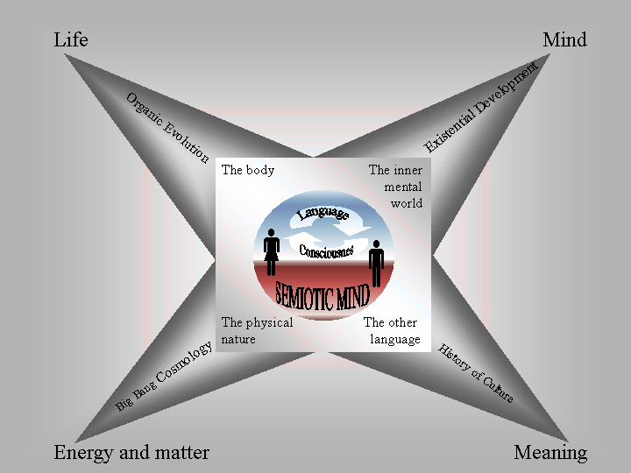

Figure 7: Visualizing how from the communicative social system of embodied minds’ four main areas of knowledge arise: Usually physical nature is explained from energy and matter, living systems are explained from the development of life processes, social sign culture are explained from the development of meaning and finally our inner mental world is explained from the development of consciousness.

As analyzed above, humans are embodied feeling and knowing cultural beings in language. My point is that this makes us exist in four different worlds that are equally real:

- Our body hood and our sharing of body hood with other living species.
- Our inner world of emotions and thoughts manifesting as mind and consciousness.
- The physico-chemical environment of the natural world.
- The cultural world of language, meaning and power.

I think that each of the four worlds calls for its own type of narrative. Physicists and chemists tend to see the universe as basically consisting of matter, energy and meaningless information. Biologists tend to end up seeing the universe as basically living. The social and cultural sciences tend to see the world as constructed from our social linguistic interpretations (unless they are dualist and accept that nature is as science describes it and only culture is constructed by man). Those dealing with the phenomenological aspect of our being tend to be rather anti-scientific and anti-realistic, often viewing the world as a product of our mind, or rather, consciousness being only a part of a linguistic system. But, with Peirce, I propose a view where we see semiotic mind at the heart of all four worlds. One of the strengths in Peirce’s semiotic philosophy is that qualia and mind -- as semiosis -- are installed in the entire metaphysics from the beginning. It is not explained as such, because it can only be deducted as a necessary prerequisite for producing the knowledge we want to discuss! However, it would be paradoxical to start our explanations by eliminating the semiosis it is produced in.

My main problem with the standard materialistic scientific evolutionary paradigm is that I cannot see how physics -- as an external science -- on the basis of the presents definitions of matter, energy and deterministic law, can ever alone furnish us with the final understanding of our inner lives and how consciousness arises. When working from an evolutionary view, combining the Big Bang theory with self-organizing thermodynamics and chemistry, adding Darwinism for biological systems, and proceeding with a somewhat materialistic theory of the development of the history of language and culture of man, there still remains the severe problem of explaining consciousness as this inner quality of perception, feeling, volition and cognition that we all experience. I do not see quantum physics, the general relativity theory or non-equilibrium thermodynamics as any particular help in relation to this problem, although they may be helpful to explain the physical aspect of consciousness (Penrose 1995).

I am, therefore, hesitant to put the understanding of Peirce’s semiotic philosophy into a scheme, explaining life and consciousness from the development of inanimate nature. As such, I consider a pansemiotic view accepting Thirdness and semiosis in inanimate nature a better approach. One of the problems of using Uexküll in the new biosemiotics is that he was an anti-evolutionary, vitalistic essentialist (Brier 2001), which is unacceptable in mainstream biology to day (I agree!). The standard view of today combines an evolutionary view with a materialist ontology based on energy as the ultimate concept (in quantum physics, general relativity theory and thermodynamics), hoping to explain life as a chemical organizational phenomenon. When realizing that this is not enough, often the aid of some kind of objectivistic information concept is sought, although this, as previously shown, adds new fundamental concepts, entities and ideas of organization to the paradigm that is foreign to its basic metaphysical conceptions. Thus the consistency of the project is violated.

The idea of Figure 7, and the epistemological turn it is illustrating, is to escape the great explanatory burden of reductionistic mainstream science, wanting to explain both life and consciousness from its basic assumption of energy and mathematical mechanistic laws. The cybersemiotic view sees scientific explanations as going from our present state, of socio-linguistically based conscious semiosis in self-organized autopoietic systems, towards a better understanding of the prerequisites of language and the self-conscious being. The reductions made in any of the four directions have to remain consistent with the point of departure in the middle and the main qualities of the other three worlds. One way to deal with this paradoxical problem would be to be less ambitious about the explanatory demands on science for the big scheme of things as Peirce shows in his deep integration of science and philosophy in semiosis. Science gives good economic understanding of certain processes, often in a way that allows prediction with a wanted precision within certain circumstances. But it does not give universal explanations of the construction of reality, energy, information, life, meaning, mind and consciousness. Science does not provide a full explanation of the world or our place in it. We produced knowledge before we had science. Knowledge is one of the big mysteries of the world, and it seems to be based on semiosis. Being in the world, in languaging, in body hood in a meaningful social context we always have to start ‘in medias res’. We will always be bound to make metaphysical presumptions based on our present understanding that will always later prove to be too limited narrow. But Peirce’s semiotics is a very good non-reductionistic framework to start from since it takes its point of departure in semiotic mind.

Somehow, we will have to enlarge the conceptual framework within which we do science if we want to make a connection, also to the phenomenological aspect of reality and deal with the experience of meaning. Our search is to explain and understand all four aspects of our reality, and our explanations from any of the corners will only be one aspect of the total picture explanation. My suggestion is to start in the middle and extrapolate out in the four corners. To try explaining all from one corner is reductionism, no matter from which. Peirce’s insistence on Secondness as an independent existence revealing itself in the end as the dynamic object for the final interpretant is an insurance against all sorts of too radical kinds of constructivism that loose their grip in reality and transform into either subjective or collective idealism.

The trans-scientific framework

It is, today, widely recognized that what we call a human being is a conscious social being, living in language. Heidegger considers language to be an intrinsic part of reality, almost a part of nature. Wittgenstein states that language bewitches the mind. Luhmann sees socio-communication as an autopoietic system, working in the environment of the human animal, i.e., our body-mind (the biological autopoiesis and the psychological autopoiesis). Terrance Deacon (1997) sees language-processing capacity as a major selective force for the human body-mind.

All the above-mentioned insights about language indicate that we are the autopoietic systems in which language emerges. We speak language, but we are also spoken by language. To a great degree language carries our cultures, theories of the world and of ourselves. As individuals we are programmed with language -- to learn a language is to learn a culture. As such, pre-linguistic children are only potentially human beings, as they have to be linguistically programmed in order to become the linguistic animal cyborgs, we call human.

But we do not have to be slaves of that (one culture) since we can learn more languages, and we reflect on common language with specially developed languages, such as scientific or poetic language.

However, getting behind language as such is difficult. Zen Buddhism, for instance, cultivate such techniques through the paradoxes of the koans. Other systems do it by going beyond linguistic meaning in the usage of internal mantras, such as Transcendental Meditation. Members of different religious systems spend long periods in silence and seclusion as a means to expand consciousness beyond language, or maybe just becoming more aware of what goes on underneath language in emotions and biological motivations that also are in play behind our linguistic self-consciousness. Phenomenological method of analyzing experience seems to go in the same direction searching after the pre-linguistic foundation for perception (Merleau-Ponty 2002 org. 1962/48). But generally we are very controlled by our language and culture in our outlook and self-understanding and it is on this level that explicit metaphysics emerge and can be discussed.

Let us, therefore, first take a look at a model that suggests how we humans build up our different knowledge systems in our culture, which again programs the children, to rise to be linguistic cyborgs who carry our language, values and worldview, and cultural conception of the human.

I suggest that culture builds up a view of what is real and what is not, what is manifest and what is not. I put these four decisions into a square inspired by Greimas’ square. We thus start with real phenomena of which some can be handled directly and some are working behind the scenes, such as laws of nature or animal spirits, invisible and blind watchmakers. See Figure 8.
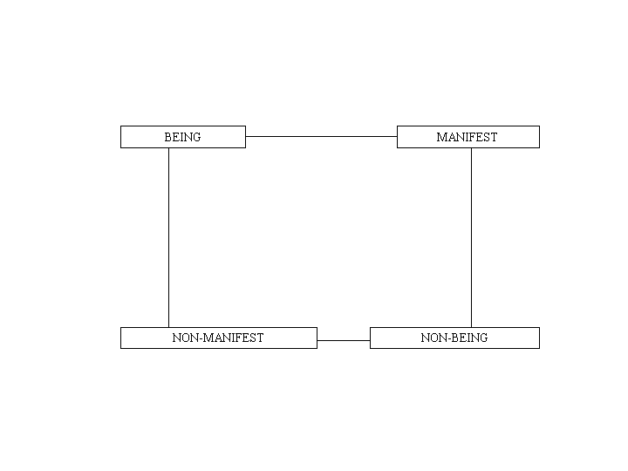
Figure 8: The first circle developed Greimas’ semiotic square and consists of two combined pairs of opposites. Objects can be characterized by their being or manifestation. True objects have both. Fictional and mythological beings have none.

In our culture we consider primarily the real and manifest to be natural ‘things’ or ‘objects’ (res). What is not real and not manifest is ‘no thing’ like the godhead, the emptiness, the empty set, zero, the vacuum field and so on. The concepts of nothingness mentioned here are very different in nature and some of them are mutually exclusive. The discussions on whether nothingness is emptiness or fullness, if it is non-rational or super-rational or if it is with or without intensions are important parts of metaphysics. I have so far referred to it as a hyper-complexity indicating that we should not expect to find any simple form of Logos there as for instance a mathematical world formula.
Manifest cultural objects are not real like natural objects. They are fictional. This goes for pieces of art and even the architecture of buildings and machines, although the parts they consist of are natural objects or ‘matter’. Real non-manifest phenomena, such as the natural laws or the meaning of life are ‘hidden’. They are to be viewed as immanent as opposed to the transcendence of nothingness. See Figure 9.

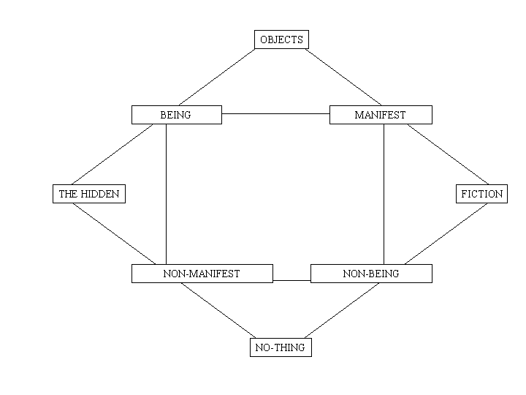

Figure 9: The second circle produces the basic objects in our culture: The real, the fictional, the hidden forces controlling object processes and, finally, the zero or negative basis for everything. That can also be viewed as a fullness of potentialities like Peirce does in his concept of Firstness.

To this construction we can add some of our basic systems of knowledge construction. Science deals with the hidden laws behind the objects and their dynamics like for instance kinematics. Religion deals with the hidden that is no-thing. Art deals with fictional objects manifest or imaginary. Politics deal with fictional no-thing phenomena like democracy, human rights, and free markets. See Figure 10.

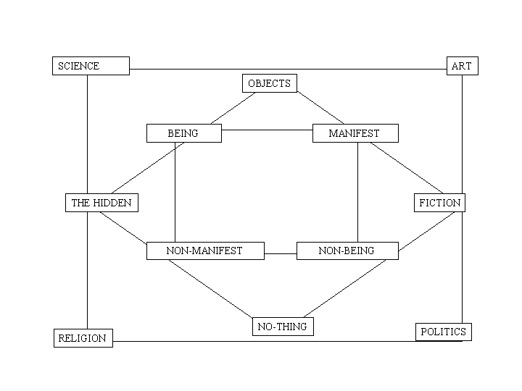
Figure 10: The third circle explains the emergence of different kinds of knowledge types related to the kind of objects our culture defines in the world. They all seem necessary and not reducible to each other.

The third culture reveals that science and art share creative aspects. This is why we use the term “production of knowledge” instead of discovery of truth or facts. We have come full circle in our culture after positivism realizing that both behind religion and science there are metaphysical assumptions or frameworks, paradigms if you like.

We also learned that our basic attitude of relating to and caring about reality and the living beings in it, as well as search for meaning and ethics are fundamental parts of the existentiality of a conscious individual in body and culture. Spirituality is the concept chosen to signify this intentionality that gives rise to political and religious, as well as scientific pursuits. Finally, arts and politics join forces in our cultural construction of social utopias. Presently, the global ecological as well as human and economic sustainable societies seem to be our new utopias, as we worry about our globe’s ability to keep the conditions stable for our survival on this planet.
See Figure 11.
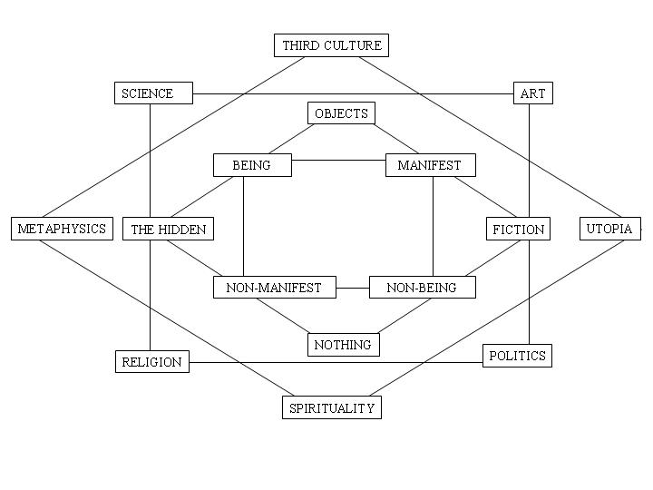
Figure 11: The fourth circle that brings forth a reflective practice to analyze and develop the foundation on which our thinking is based. Thus revision and development is possible. This is one of the very important uses of philosophy of science.

This way of constructing our human and cultural knowledge system, collecting the four levels, leads to a model like the one below. It shows how the different knowledge systems interact, bringing forth our ideas of utopias worth pursuing through our political, spiritual, philosophical and scientific systems. The model is an example of Third culture as it combines traits from art and science and in itself is somewhat utopian. It is, of course, a simplification playing on a picture’s ability to say more than a thousand words, but still needing a lot of words to set its context of interpretation and describe its limitations.

The Cybersemiotic Frame Work
The Cybersemiotic approach interacts with, is based on, and supports such a trans-scientific framework that provides science with a wider scope concerning the survival and construction of meaning and culture. These basic conceptualizations are, of course, semiotic significations giving meaning to the world, its differences and constraints.

Semiotics starts with the process of knowledge; how signification is taking place in living systems, making perception and cognition possible. Peirce’s semiotics unites our explanatory schemes of deduction and induction through abduction within the process of semiosis. Peirce suggests that we look at triadic semiosis as the fundamental process of reality. Consciousness builds on semiotic processes. Biosemiotics acknowledge semiosis as an essential part of all living systems, and that semiotics must have the sign games of all living systems as its subject area. Cybernetics and semiotics can therefore, in a most useful manner, be joined together in the greater framework of cybersemiotics.

Figure 12: A view of Cybersemiotics: The model illustrates the way in which two major trans-disciplinary research programs have complementary approaches to the subject of information, cognition, signification and communication. The inner square shows the four qualitatively different approaches to the study of information, cognition and signification in man and animals. They are complementary and are in my opinion not possible to integrate into one science of psychology or cognitive science. Attempting to unite several, but a different selection, of these approaches are two competing trans-disciplinary approaches. One of them is cybernetics and systems science's information processing paradigm, which have been developed into the linguistic area through cognitive science and Chomsky's linguistics. The other approach is the pragmatic semiotics of Peirce connected with pragmatic language philosophy like Wittgenstein's language games theory and linguistics and Lakoff and Johnson's experientalistic cognitive semantics. Cybernetics is a functionalistic approach based on an objective information concept and semiotics is a phenomenological approach based on a pragmatics concept of meaning. Cybersemiotics is then an attempt to make a meta-framework uniting phenomenology and functionalism in a pragmatic, evolutionary non-reductionistic triadic view on the self-organization of signs and signification processes for studies in information, cognition, signification and communication. The figure is quoted from brier (2000d).

If we look again at Figure 7, we can see that semiosis and autopoietically constructed living systems can be used to encompass the basis of knowledge production. Although the figure has four corners, it is actually in accordance with Peirce’s triadic metaphysics because of the life and mind corners. Life, mind with its feeling ability are the Firstness in which the qualities exist. One interpretation of Firstness is as ‘life itself’, mind, raw feeling and the possibility of the production of interpretants is based here.

As we have already analyzed them, true natural objects arise only from the energy/matter habits of the universe. These are the true Secondness dualistic functions. The meaning and understanding of both nature and the living mind is produced in culture. Thirdness and significations are made here. Culture is the ceaseless production of interpretants in semiotic webs. Interpretations are continuous interaction and development, creating and recreating new language games in the interaction with the development of new life forms. These new life forms are produced, among other things, through the development of new technologies. In our time, IT and the Internet are strong generators of new language games. I therefore want to end this article with a few words on the evaluation of the development of new technologies with the developed framework as a basis.

Conclusion

I have made the point that we live in at least four different worlds and cultivate knowledge-systems within each of them. I argued that we must cease to try to explain the world and ourselves from only one corner. Instead, we have to accept that we live in a hyper-complexity that will never be completely reduced to a simple explanation. This complexity and our incomplete conceptualised knowledge of the world and ourselves are vital parts of the conditions of being a mortal human in time and space. From this condition also rises our individual freedom and individual possibility of giving meaning to our own lives! Every technology we develop has to respect and cherish this human complexity and meaning-producing situation, or what we could call the human condition, which also includes our narrative skill of reasoning that sustains our broader existential view of meaning. This goes beyond the truth tables of analytical philosophy’s concept of meaning, in its ability to produce knowledge and signification. This specific human type of meaning-production seems to be essential to our being-in-the-world, and should therefore be supported. Consequently, our personal ways of organizing knowledge around what we conceive as meaningful narrations should be respected, and the development supported.

I may be “accused” for being progressivistic in the approach underlying my project in some Hegelian way. Yes, I believe that we do make progress in our knowledge, I do not believe in some point Alpha to be the final goal for humanity in the development of our explicated culturally developed knowledge. But I do believe with both Popper and Kuhn that we develop our knowledge to cover more ground and in more consistent ways, compared to when we first started to put philosophy in writing, or compared to what we did a 100 years ago. Finally, with Niels Bohr, I believe that when we expand our subject areas of knowledge, we often end up in the situation, as quantum mechanics did, where our old conceptual foundation cannot handle the new problems. Therefore we have to expand our foundations, as Bohr attempted with his complementarity theory as a means of understanding quantum physics. This is what I have attempted for a much broader area. However this limited space narrows down the argumentation, and I therefore refer to my previously published papers, included in the list of references. A book with more comprehensive argumentation is forthcoming on Toronto University Press.

References
Brier, S. (1992): A Critique of the Mechanistic Foundation for the Concept of Information, Cybernetic Human Knowledge, pp. 71-94 V. 1. No. 2/3.

Brier, S. (1996):”From Second-order Cybernetics to Cybersemiotics: A Semiotic Re-entry into the Second -order Cybernetics of Heinz von Foerster”, Systems Research, Vol. 13, No. 3, pp.229-244, 1996.

Brier, S. (1997a). The Self-Organization of Knowledge: Paradigms of Knowledge and their Role in the Decision of what counts as legitimate medical Practice. In Studies in Alternative Therapy 4: Lifestyle and Medical Paradigms, Gosvig, S et al. INRAT, Odense University Press: 112-135.

Brier, S. (1998): “Cybersemiotics: a transdisciplinary framework for information studies”, BioSystems 46 (1998) 185-191.

Brier, S. (1999a): “What is a possible ontological and epistemological framework for a true universal “Information science? The suggestion of a cybersemiotics”. World futures general evolution studies; The quest for a unified theory of Information: Proceedings of the 2. International Conference on the Foundations of Information Science, 1996, Vienna, Austria, 79-99.

Brier, S. (1999b): ”The Self-Organization of Knowledge in a World of Complexity: The Interplay of Paradigms of Knowledge in the Non-Cartesian Transdisciplinary Epistemological Framework of Cybersemiotics”, Proceedings from the 43rd Annual Conference of The International Society for the Systems Sciences, 28. June-2. July, Asilomar, Ca, USA. CD-ROM , Article no. 99122.

Brier, S. (1999c): “Biosemiotics and the foundation of cybersemiotics. Reconceptualizing the insights of Ethology, second order cybernetics and Peirce’s semiotics in biosemiotics to create a non-Cartesian information science”, Semiotica, 127-1/4, 1999, 169-198. Special issue on Biosemiotics.

Brier, S. (2000a): “Konstruktion und Information. Eine semiotische re-entry in Heinz von Foersters metaphysische Konstruktion der Kybernetik zweiter Ordnung ”, in Oliver Jahraus, Benjamin Marius and Nina Ort (ed.): "Beobachtungen des Unbeobachtbaren"/"Observations of the Unobservable", Velbrück edition Metzler Verlag. English version of article “Construction and information: A semiotic re-entry into Heinz von Foerster’s metaphysical construction of second order cybernetics” forthcoming in CCIS Journal, Toronto, V. no.1, 2003.

Brier, S. (2000b): “Cybersemiotics As A Suggestion For FIS”. Proceedings of The World Congress of the Systems Sciences And ISSS 2000, International Society for the Systems Sciences, 44th Annual Meeting, July 16-22, 2000, Toronto, Ontario Canada. Article No. 20150 – CD-ROM.

Brier, S. (2000c): “Transdisciplinary frameworks of knowledge”. Systems Research and Behavioral Science. Vol. 17, No. 5, pp.433-458.
Brier, S. (2000d). “Biosemiotic as a possible Bridge between Embodiment in cognitive Semantics and the Motivation concept of Animal cognition. in Ethology”. Cybernetics & Human Knowing, 7(1), pp 57-75.

Brier, S. (2001): “Cybersemiotics and Umweltslehre”, Semiotica. Special issue on Jakob von Uexküll, 134-1/4, pp. 779-814.
Deacon, T.W. (1997): The Symbolic Species: The co-Evolution of Language and the Brain. New York: Norton.
Deeley, J. (1990): Basics of Semiotics, Bloomington, Indiana University Press.
Deeey, J. (2001): “Physiosemiosis in the Semiotic Spiral: A play of amusement”, Sign System Studies 29/1, pp. 27-48.

Geyer, F. (1995). “The challenge of Sociocybernetics”, Kybernetes, 24, 4, pp. 6-32.

Merell, F (1996): Signs Grow: Semiosis of Life Processes. Toronto: University of Toronto Press.

Luhmann, N. (1995): Social Systems. Stanford, California: Stanford University Press
Luntley, M. (1995): Reason, Truth and the Self: The Postmodern Reconditioned. London: Routledge.
Merleau-Ponty, M. (2002 org. 1962/48): Phenomenology of Perception. Translated by C. Smith. London: Routledge & Kegan Paul. Originally published as Phenomenologie de la Perception (Paris, Callimard, 1945, English 1962)

Michael Polanyi (1973): Personal knowledge: Towards a post-critical philosophy
(Repr.), London: Routledge & Kegan Paul.

Penrose, R. (1995): Shadows of the Mind: A Search for the Missing Science of Consciousness, London: Oxford University Press.

Sebeok, T.A. (1963): “Communication in Animals and Men”, Language 39, pp. 448-466.

Sebeok, T .A. (1976): Contribution to the doctrine of Signs, Bloomington: Indiana University Press.

Smith, B. C. (1998): On the origin of Objects. A Bradford Book. The MIT Press, Massachusetts Institute of Technology. Cambridge, Massachusetts, London, England.

Stonier, T (1997): Information and meaning: An Evolutionary Perspective, Berlin: Springer.

The present article gives an overview of the last five years of my inter- and trans-disciplinarily work with establishing a philosophical foundation for a transdisciplinary framework that could make it possible to construct an analytical tool of information science (FIS). As such it draws on several published papers (especially Brier 2000c).
In this paper I present the arguments in short form, further I use visual models as an attempt to synthesize the view in one picture. For further argumentation, please see the original articles. I use a lot of figures to represent my ideas, despite many colleagues from the humanities and social science, who often remind me that they reduce the complexity of the subject area. I do this, partly because of my background in the sciences, and partly due to my belief in Herman Hesse’s idea of the Glass-bead-game, and the idea of a third culture between art and science. As the amount of knowledge keeps growing exponentially and the subject areas we deal with are getting exceedingly complex, more concentrated ways of conveying knowledge must be applied.
This model builds on presentations by Peter Voetmann Christiansen to a Mind Ship Seminar in Copenhagen in 1996. Here, the idea was sketched, and with the permission of Peter Voetmann Christensen , I have further developed it. I wish to thank Peter for many years of inspiration.

